**Recruit Right**: Precision Hiring with AI Insight

### Project Proposal

## 

## HU logo High Resolution.png

## Supervisor(s)

Dr. Umer Farooq

Ms. Muntaha Mehboob { former }

## Submitted by

Muhammad Naeemuddin

{1955-2021 /IT-21-159 }

Muhammad Abdullah

{2206-2021 / IT-21-148}

Muhammad Raza

{2207-2021 / IT-21-160 }

**Department of Computer Science,**

Hamdard University, Karachi.

[27th June, 2024]

# Introduction

This project aims to revolutionize technical interviews by automating personality assessment, remote live coding and asynchronous video interviews. These interviews will be evaluated by experts, providing structured feedback. Our platform will enable the outsourcing of technical screenings at scale, using a global pool of vetted engineers to conduct these interviews.

By standardizing evaluations, we aim to streamline the hiring process, saving time and reducing risk. Our automation will transform the interview process, making it more efficient and consistent, and allowing companies to focus on the most suitable candidates more quickly. This project emphasizes integrity, accountability, innovation, collaboration, customer focus, and excellence in every aspect.

# Objective

To create a technical interview outsourcing platform that conducts interviews on behalf of companies, enabling hiring teams to focus on candidates that meet their standards.

# Problem Description

A growing logistics company faced significant challenges with its manual technical hiring process. The inefficiencies of this approach resulted in prolonged hiring timelines, difficulties in coordinating interviews, and inconsistent candidate assessments. These shortcomings contributed to high turnover rates and increased operational costs for the company.

The manual process required the hiring team to handle interview scheduling, create assessment questions independently, and manage candidate progress across various platforms. This fragmented approach not only consumed considerable time but also led to errors and delays. Moreover, the lack of standardized assessment questions hindered the company's ability to consistently evaluate candidates' technical proficiency.

Transitioning to a more efficient hiring process became crucial for the company to enhance operational efficiency, reduce time-to-hire, and improve the quality of technical hires. The need for an automated solution was evident to streamline operations and optimize the hiring process effectively.

# Methodology

Our approach centers on using a modern tech stack and integrating key third-party APIs to ensure scalability and performance. Advanced algorithms will be implemented for features like cheating detection and candidate evaluation analytics. User-centric design principles will guide the creation of an intuitive platform, incorporating tools such as real-time code editing, interview playback, and collaborative notes.

In addition to the core functionalities, this project explores the potential of using facial gesture analysis to gauge candidate confidence during interviews. However, it's important to acknowledge that this aspect is considered a future enhancement. Our initial focus will be on establishing a robust platform with keyword detection for efficient resume and interview evaluation. Integrating facial gesture analysis requires further research and development, and will be pursued in later iterations to refine the assessment process.

Our architecture will emphasize scalability through microservices, aiming to enhance the technical interview process with a flexible and cost-effective solution tailored to meet diverse organizational needs.

# Project Scope

The scope of our project is defined by creating a streamlined hiring process akin to the outlined steps, while excluding certain aspects to maintain clarity and feasibility. Our focus will be on developing a user interface and workflow that replicates Steps 01 to 03 of the hiring process:

1. Customization of interview plans in collaboration with expert solutions engineers.
2. Utilization of a network of skilled Interview Engineers for efficient candidate evaluation.
3. Implementation of a reliable assessment process to advance qualified candidates and extend offers effectively.

We will not address backend integration with existing HR systems or the development of proprietary assessment algorithms beyond the scope of public access. Assumptions regarding user interface responsiveness will guide our system's evolution, ensuring a straightforward implementation without delving into irrelevant technical details such as communication media specifics.

In summary the scope includes:

* Making a user friendly front-end.
* Connecting it to a backend.
* Testing the project on dummy data.
* Deployment of the project on firebase.

# Feasibility Study

Considering the defined scope, we aim to meet our project schedule. Key aspects to consider include:

* 1. **Risks Involved**: Risks include potential delays in front-end development and integration challenges between the front-end and backend systems. Mitigation strategies involve conducting thorough testing during each development phase and maintaining clear communication among team members to promptly address any issues that arise.
  2. **Resource Requirement**: Here are some general minimum system requirements that can be considered at this point:
* CPU: Dual-core processor or higher with clock speed of 2.5 GHz or more.
* RAM: At least 8 GB of RAM is recommended for better performance.
* Storage: The minimum storage space required is 500 GB for smooth operation, but it can vary depending on the site's content and functionality. It is important to consider the size of data.

# Solution Application Areas

This project targets several important industry and application domains, offering tailored benefits to address specific needs:

* **Startups:** Our solution provides instant, affordable, scalable, and standardized tools aimed at helping startups streamline their hiring processes. By simplifying recruitment, it enables startups to focus more on core product development activities.
* **IT Staffing and Recruiting Companies:** Tailored for delivery managers, business heads, and recruiters in the IT staffing sector, our solution improves recruiter efficiency, standardizes operations, and optimizes Profit & Loss statements, leading to enhanced organizational performance.

# Tools/Technology

For this project, the essential tools and technologies include:

**Hardware:**

* Personal computers or laptops
* Mobile devices (optional for testing)

**Software:**

* Front-end: HTML, CSS, JavaScript, Express.js, Flask
* Back-end: Node.js, Express.js, MongoDB, Python
* Testing: Jest

These tools will support the development, testing, and deployment phases of the project, ensuring efficient workflow and successful implementation of the hiring process application. Adjustments may be made based on specific project requirements and scalability considerations.

# Responsibilities of the Team Members

Having equal interest in the project, we have worked together in many projects using multiple technologies. Along with this, we are enrolled in same program with similar interests. During our summer break, we will be having more opportunities to learn more technologies required for our project which will cover the front-end and back-end.

# 10. Milestones:

* + **Project Initiation Phase:**
  + Describe project objectives and scope.
  + Project approval.
  + Create project plan and timeline.
  + Determine the use case and actors.
  + **Design and development Phase:**
  + Documentation
  + Designing the UI/UX.
  + Backend development.
  + Connecting the front-end and backend.
  + **Testing and Quality assurance phase:**
* Unit testing.
* Integration testing.
  + **Deployment and launch phase:**
  + Choosing hosting plans for website deployment.
  + Ensuring scalability.
  + Launch the website.

# A gantt chart with a graph Description automatically generated11. Project Schedule

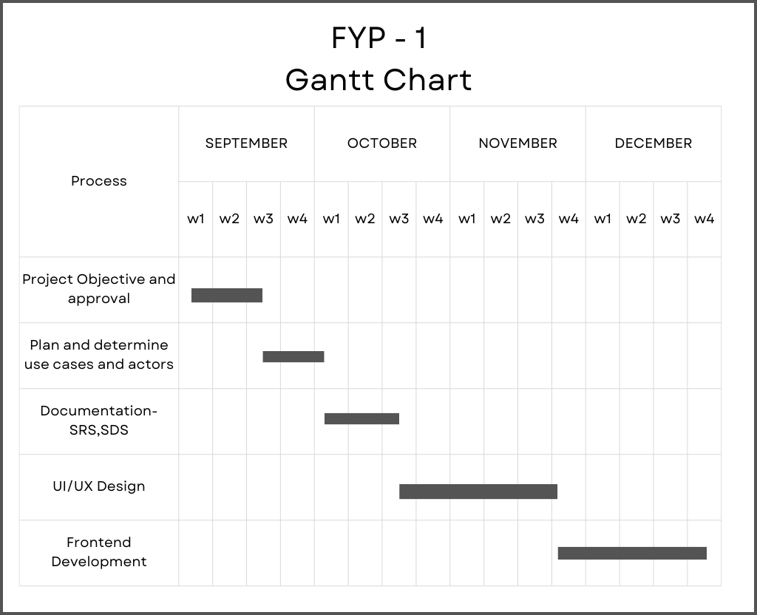

# 12. References

[1] Internet Web page: Author. “karat”. https://karat.com/.

[2] Internet Web page: Author. “intervue.io”. <https://www.intervue.io/>.

[3] Mehboob, Muntaha & Ali, Saad & ul Islam, Saif & Ali, Syed. (2022). Evaluating Automatic CV Shortlisting Tool For Job Recruitment Based On Machine Learning Techniques. 1-4. 10.1109/MAJICC56935.2022.9994112.